
Haji Mohamed Yunus Valibhoy Community Centre
Serving Humanity · Dhari, Gujarat, India
Community Centre Management System
UI Design Specification · Desktop Web (Next.js) & Mobile
Version 1.0 · 22 October 2026
Prepared by Mutant Technologies
22 desktop pages · 9 mobile screens · shared layout components

Contents
1. Overview
2. Design System
3. Next.js Route Map
4. Desktop Pages
4.1 Login
4.2 Dashboard
4.3 Dashboard Analytics
4.4 Bookings List
4.5 New Booking
4.6 Booking Details & Timeline
4.7 Calendar
4.8 Customers
4.9 Customer Profile & Ledger
4.10 Payments & Expenses
4.11 Deposit Refund
4.12 Invoices & Receipts
4.13 Maintenance Requests
4.14 New Maintenance Request
4.15 Property Inspection
4.16 Attendance (GPS)
4.17 Approvals
4.18 Notification Center
4.19 Global Search
4.20 Reports & Export
4.21 Activity & Audit Logs
4.22 Users, Roles & Permissions
5. Mobile Screens
5.1 Login
5.2 Dashboard
5.3 More Menu
5.4 Notification Center
5.5 Global Search
5.6 Bookings List
5.7 New Booking
5.8 Booking Details & Timeline
5.9 Calendar
6. Files in this Package

1. Overview
This document describes the user interface for the Community Centre Management System, based on the Mutant Technologies project proposal and the client’s reference screens. Every module in Phase 1 has a designed page. The designs are built for a responsive Next.js web application (PWA) that works on desktop, tablet and mobile.
MODULES COVERED
- User management, roles and permissions
- Dashboard and dashboard analytics
- Booking management, booking timeline and calendar (day, week, month)
- Customer management with ledger
- Payments, expenses and overdue alerts
- Deposit refund workflow
- Property inspection (before and after)
- Maintenance requests, quotations and calendar blocking
- GPS attendance
- Approvals (expense, maintenance, refund)
- Notification center, global search, invoice generator
- Reports with PDF and Excel export, activity and audit logs
ASSUMPTIONS TO CONFIRM WITH THE CLIENT
- Three venues (Main Hall, Conference Hall, Garden Lawn), booked separately or together
- Bookings can run over multiple days, and one hall can have more than one booking per day
- Roles: Admin, Manager, Accountant, Staff
- All names, phone numbers and amounts in the screens are sample data
- Placeholders still open: centre phone number, maximum upload size, GPS geo-fence radius
- WhatsApp, SMS and Email notifications are Phase 2 and shown as such
INTERACTIVE PROTOTYPE
The same designs exist as a clickable canvas. In Play mode the sidebar and links move between pages, and filters, tabs, calendar days, approvals, checklist items, check-in/out, invoice types, report tabs and the permission grid all respond.

2. Design System

Brand colours
Token | Colour | Used for
Navy (primary) | #0B2A5B | Sidebar, headers, primary buttons, headings
Gold (accent) | #C9971C | Active nav item, highlights, chart emphasis, dividers
Light gold | #E2B544 | Logo ring, active sidebar fill, gold buttons on navy
Cream (background) | #FBF6EC | Page background, inner card fills
Card border | #EFE4CC | Card and table borders
Ink (text) | #14213D | Body text
Muted text | #5B6474 | Labels, secondary text

Status colours
Used the same way everywhere: badges, calendar chips, timelines and filters.
Status | Colour | Meaning
Confirmed | #15803D | Booking confirmed; payment received; check passed
Pending | #F5B700 | Waiting for payment or decision (dark text on this colour)
Approved | #1D4ED8 | Approved by an admin
Cancelled / Overdue | #C62828 | Cancelled booking, overdue payment, damage issue
Maintenance / In Progress | #6D28D9 | Calendar blocks and work in progress
Completed | #4B5563 | Finished bookings and closed tickets

Typography
Item | Specification
English | Poppins 400 / 500 / 600 / 700 (Google Fonts)
Gujarati | Noto Sans Gujarati 400 / 600 / 700, used for the centre name
Page title | 20–24 px, 700, navy
Card title | 16–17 px, 700, navy
Body / table | 13–14 px, 400–600
Labels | 11–12 px, 600, muted or gold uppercase for section labels

Shape, spacing & components
Item | Specification
Corner radius | Cards 16 px, inputs and buttons 10–12 px, badges 8 px, chips fully rounded
Spacing | Page padding 28 px desktop / 16 px mobile; gaps 12–20 px
Touch targets | At least 44 px high for buttons, inputs and nav items
Buttons | Primary navy fill; secondary navy outline; destructive red outline; gold fill on navy panels
Icons | Simple 2 px stroke line icons (Lucide-style)
Responsive | Sidebar stacks above content on narrow screens; grids reflow; wide tables scroll sideways inside their card

3. Next.js Route Map
App Router structure. All pages inside the (app) group share one layout with the sidebar and top bar.
Page | Route | File
Shared layout | — | app/(app)/layout.tsx
Login | /login | app/(auth)/login/page.tsx
Dashboard | /dashboard | app/(app)/dashboard/page.tsx
Dashboard Analytics | /analytics | app/(app)/analytics/page.tsx
Bookings List | /bookings | app/(app)/bookings/page.tsx
New Booking | /bookings/new | app/(app)/bookings/new/page.tsx
Booking Details & Timeline | /bookings/[id] | app/(app)/bookings/[id]/page.tsx
Calendar | /calendar | app/(app)/calendar/page.tsx
Customers | /customers | app/(app)/customers/page.tsx
Customer Profile & Ledger | /customers/[id] | app/(app)/customers/[id]/page.tsx
Payments & Expenses | /payments | app/(app)/payments/page.tsx
Deposit Refund | /deposits/[id] | app/(app)/deposits/[id]/page.tsx
Invoices & Receipts | /invoices/[id] | app/(app)/invoices/[id]/page.tsx
Maintenance Requests | /maintenance | app/(app)/maintenance/page.tsx
New Maintenance Request | /maintenance/new | app/(app)/maintenance/new/page.tsx
Property Inspection | /inspections/[id] | app/(app)/inspections/[id]/page.tsx
Attendance (GPS) | /attendance | app/(app)/attendance/page.tsx
Approvals | /approvals | app/(app)/approvals/page.tsx
Notification Center | /notifications | app/(app)/notifications/page.tsx
Global Search | /search | app/(app)/search/page.tsx
Reports & Export | /reports | app/(app)/reports/page.tsx
Activity & Audit Logs | /audit-logs | app/(app)/audit-logs/page.tsx
Users, Roles & Permissions | /settings/users | app/(app)/settings/users/page.tsx

Shared layout
Sidebar (260 px, navy): logo, English and Gujarati name, grouped navigation (Overview, Bookings, Finance, Facility, Admin) with count badges, Logout. Top bar (white): breadcrumb and page title, global search with Ctrl K hint, today’s date, notification bell with unread count, user menu.
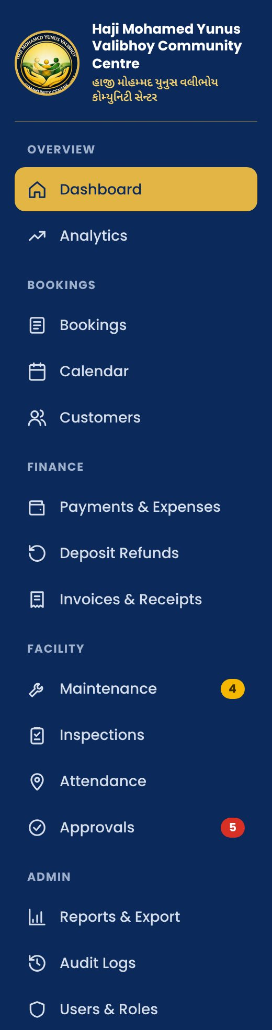

4. Desktop Pages
One page per screen: what it is for, what it contains and anything the developer should know. Screenshots are at 1440 px width.

4.1 Login
Route: /login File: app/(auth)/login/page.tsx
Secure sign-in for all staff roles. Split layout: branded panel with logo, English and Gujarati name on the left, sign-in card on the right.
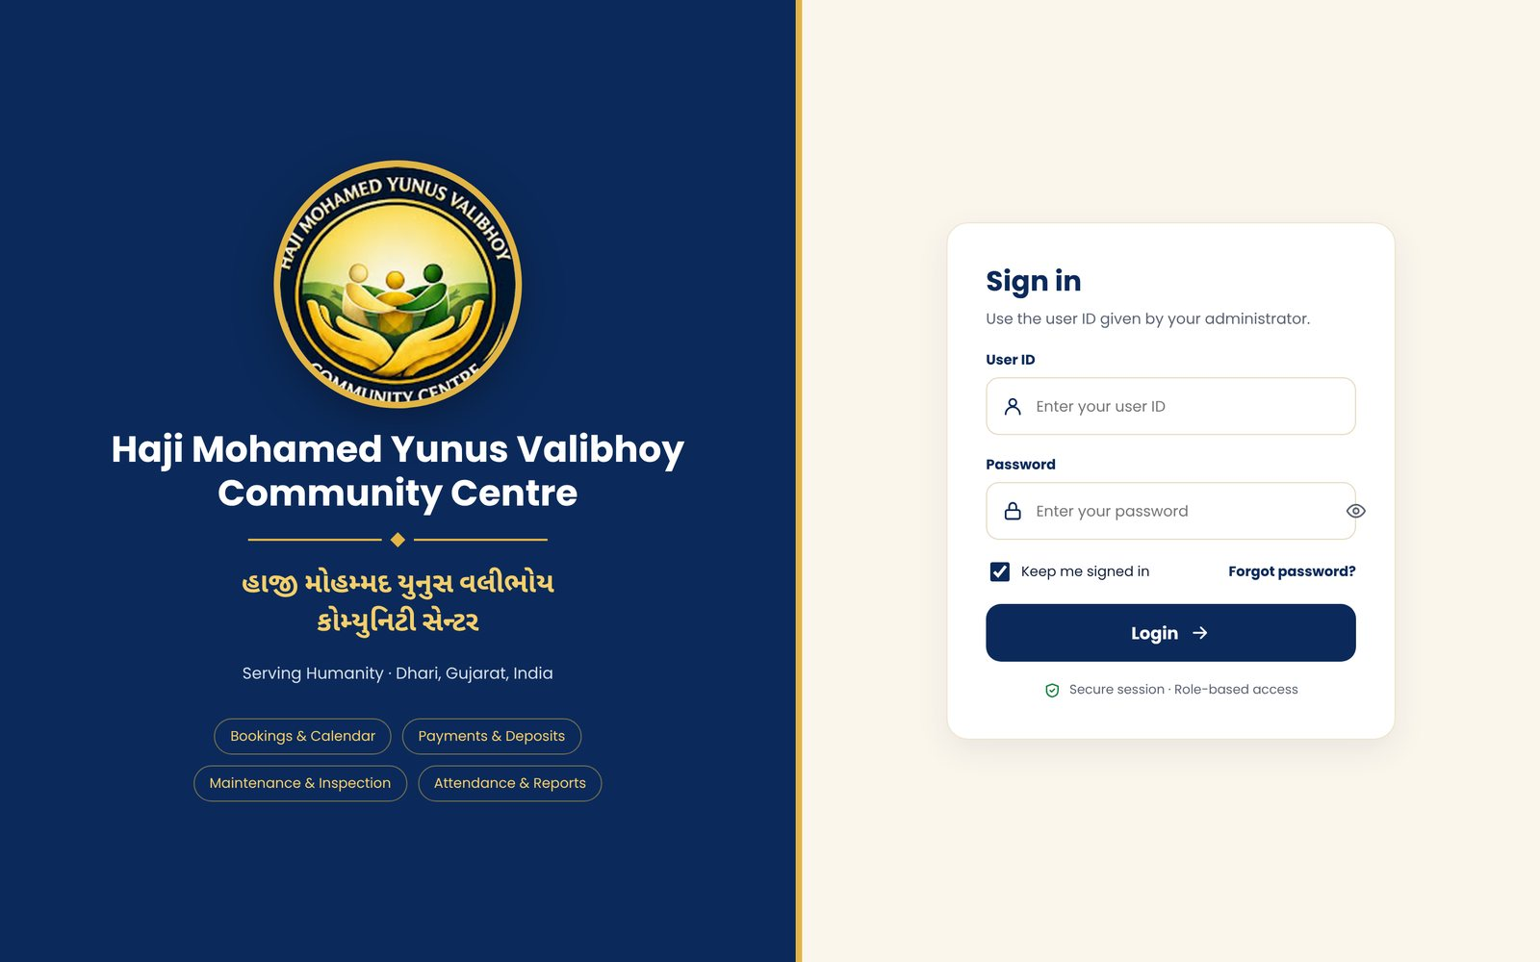
KEY ELEMENTS
- User ID and password fields with show/hide password
- Keep me signed in, Forgot password link
- Login button leads to the Dashboard
- Module chips summarising what the system covers
NOTES
Session authentication and role checks happen after login. Panels stack vertically on tablet and phone.

4.2 Dashboard
Route: /dashboard File: app/(app)/dashboard/page.tsx
Operations summary for the day: what is happening now and what needs attention.
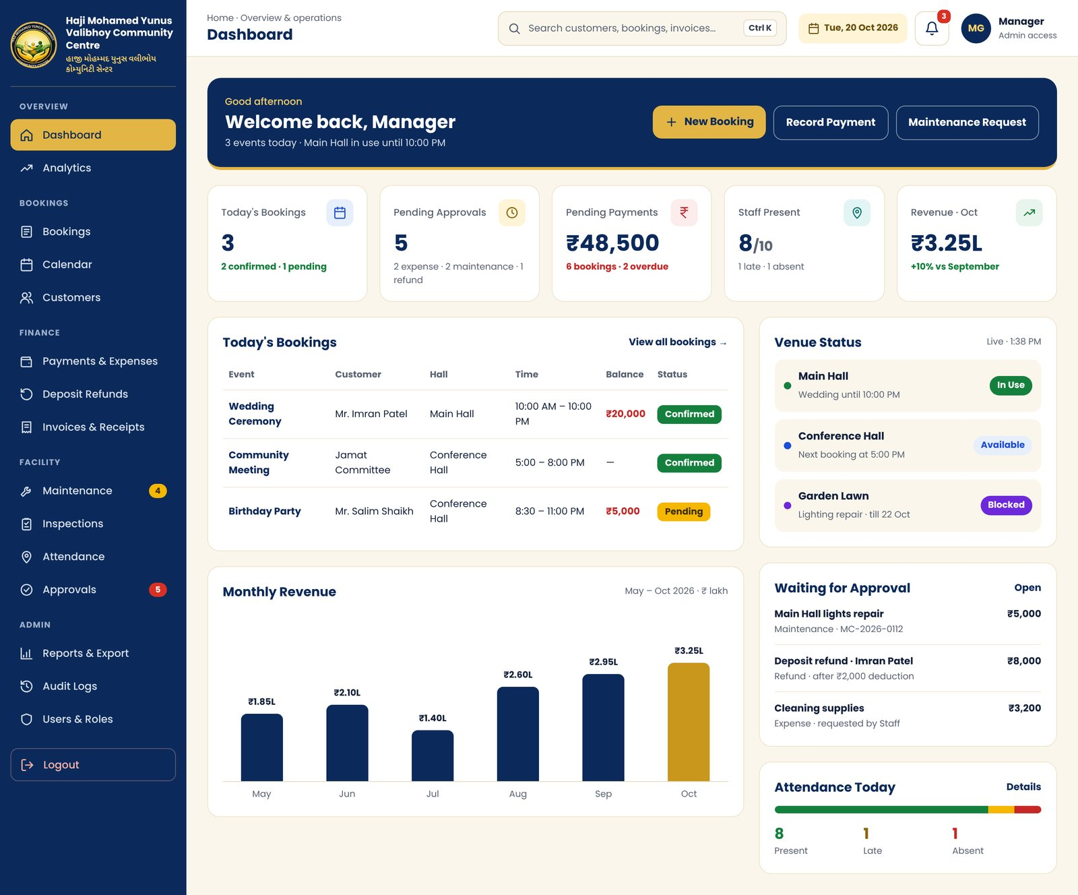
KEY ELEMENTS
- Welcome banner with quick actions: New Booking, Record Payment, Maintenance Request
- Five KPI cards: Today’s Bookings, Pending Approvals, Pending Payments, Staff Present, Revenue
- Today’s Bookings table with balance and status
- Live Venue Status for each hall (In Use, Available, Blocked)
- Monthly Revenue bar chart (6 months)
- Waiting for Approval list and Attendance Today bar
NOTES
Every card links to its module. Covers proposal items 02 Dashboard and 16 Dashboard Analytics (summary).

4.3 Dashboard Analytics
Route: /analytics File: app/(app)/analytics/page.tsx
Trends for management: revenue, bookings, expenses and hall usage.
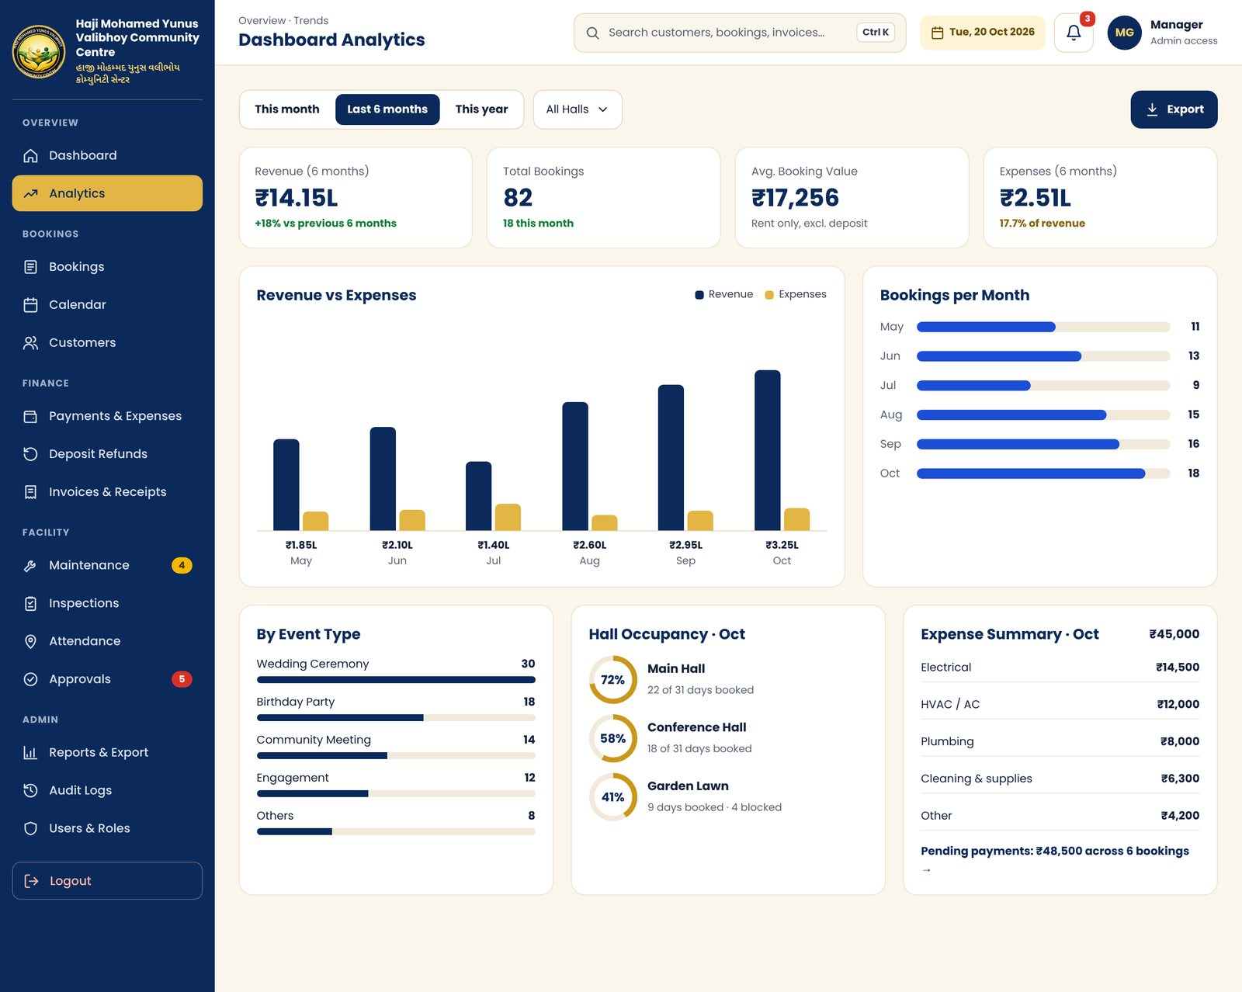
KEY ELEMENTS
- Period switch: This month, Last 6 months, This year; hall filter; Export
- KPI row: revenue, bookings, average booking value, expenses
- Revenue vs Expenses grouped bar chart
- Bookings per month, By Event Type, Hall Occupancy rings
- Expense summary by category with link to pending payments
NOTES
Period tabs are interactive in the prototype.

4.4 Bookings List
Route: /bookings File: app/(app)/bookings/page.tsx
Find, filter and manage all bookings.
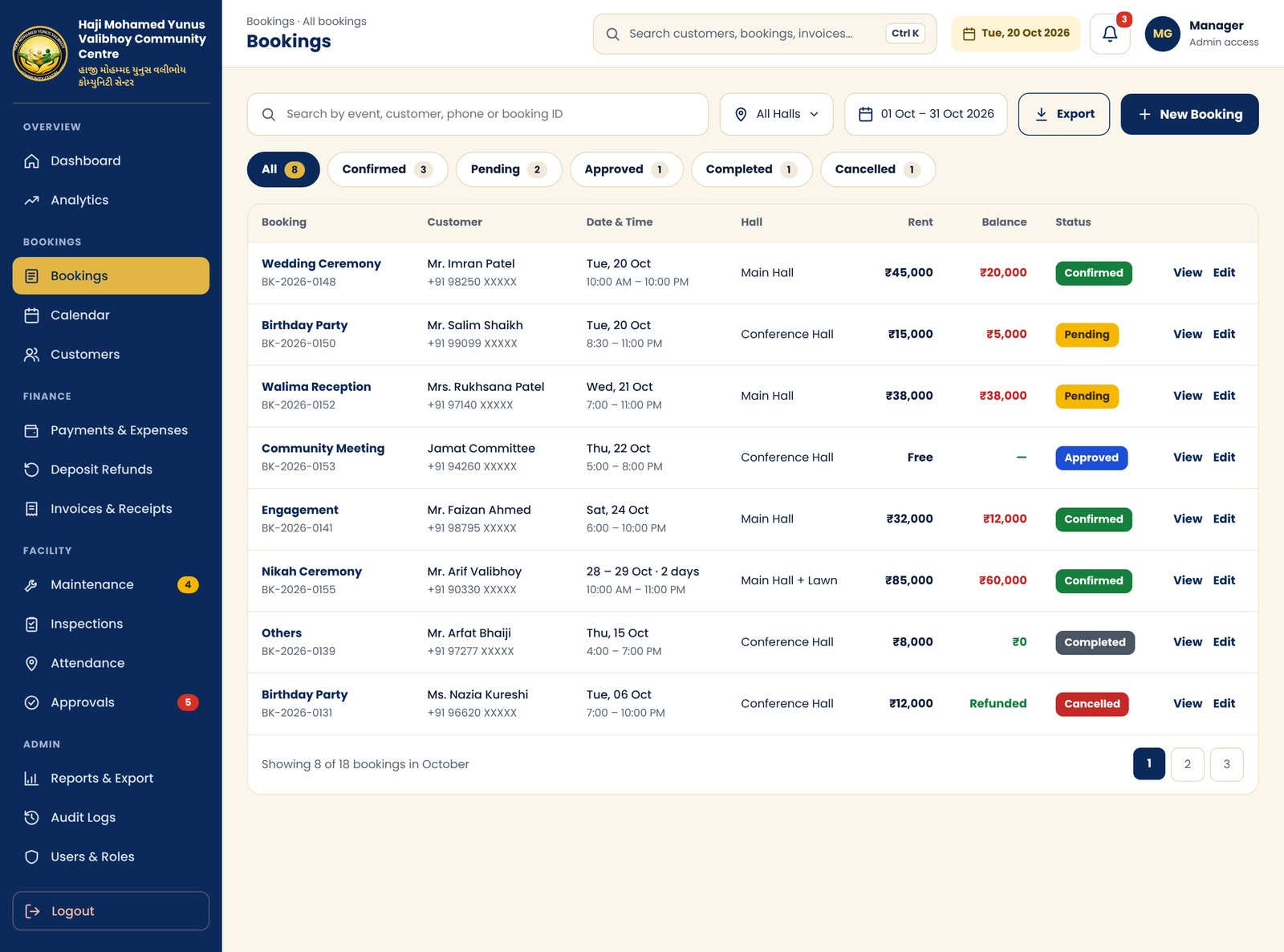
KEY ELEMENTS
- Search by event, customer, phone or booking ID
- Hall and date-range filters, Export, New Booking
- Status tabs with counts: All, Confirmed, Pending, Approved, Completed, Cancelled
- Table: booking, customer, date and time, hall, rent, balance, status, View and Edit
- Pagination
NOTES
Balance shows red when money is still due. Table scrolls sideways on small screens.

4.5 New Booking
Route: /bookings/new File: app/(app)/bookings/new/page.tsx
Create or edit a booking, including multi-day and multi-hall bookings.
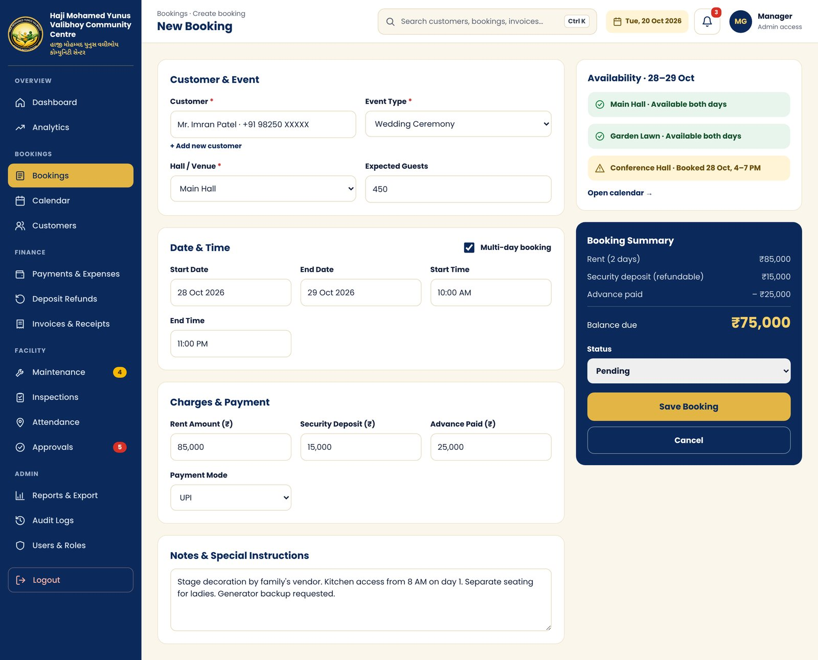
KEY ELEMENTS
- Customer search with Add new customer
- Event type, hall or venue, expected guests
- Multi-day toggle with start and end dates and times
- Rent, security deposit, advance paid, payment mode
- Notes and special instructions
- Side panel: live hall availability and booking summary with balance due, status, Save
NOTES
The availability panel should warn about clashes before saving. The same form is used for Edit.

4.6 Booking Details & Timeline
Route: /bookings/[id] File: app/(app)/bookings/[id]/page.tsx
Everything about one booking in one place.
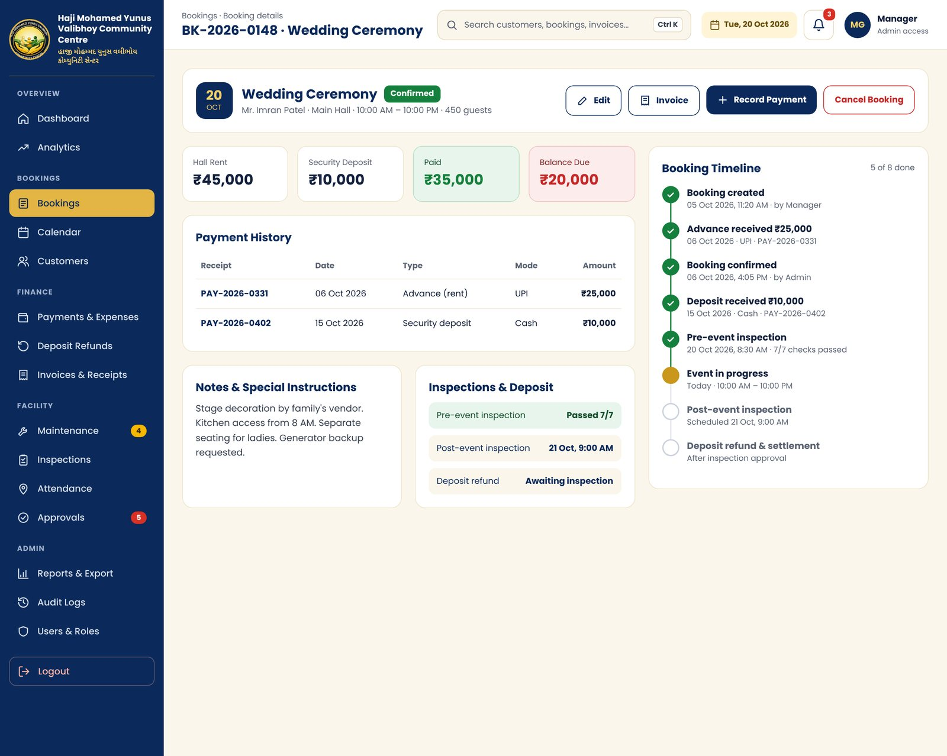
KEY ELEMENTS
- Header with event, customer, hall, time, guests and status; Edit, Invoice, Record Payment, Cancel
- Rent, deposit, paid and balance cards
- Payment history table with receipt links
- Notes, plus inspection and deposit status links
- Booking Timeline from creation to settlement (8 steps)
NOTES
Covers proposal item 13 Booking Timeline. Timeline entries come from the audit log.

4.7 Calendar
Route: /calendar File: app/(app)/calendar/page.tsx
Month view of all halls, colour-coded by status, with maintenance blocking.
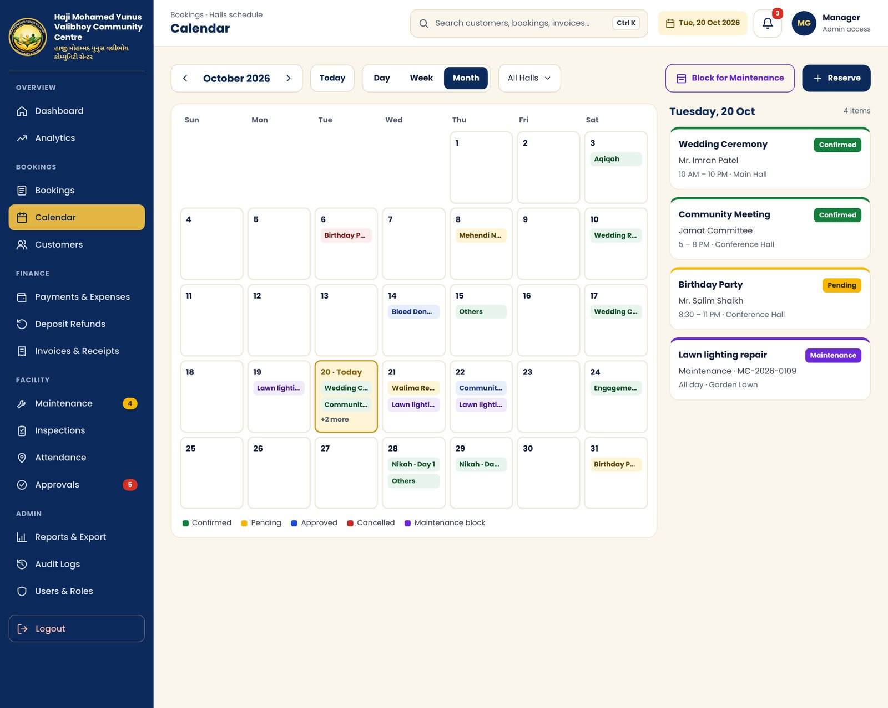
KEY ELEMENTS
- Month navigation, Today, Day / Week / Month views, hall filter
- Block for Maintenance and Reserve actions
- Day cells show up to two event chips and "+N more"
- Selected-day panel lists every booking and block for that date
- Legend: Confirmed, Pending, Approved, Cancelled, Maintenance
NOTES
Clicking a day updates the side panel in the prototype. Day and Week views follow the same colour rules.

4.8 Customers
Route: /customers File: app/(app)/customers/page.tsx
Customer directory with dues at a glance.
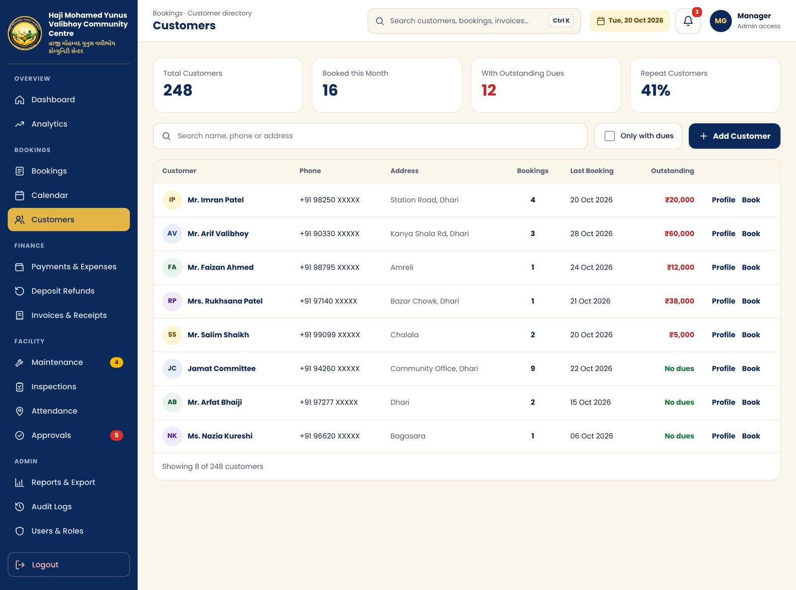
KEY ELEMENTS
- KPIs: total customers, booked this month, with dues, repeat rate
- Search and "Only with dues" filter, Add Customer
- Table: name, phone, address, number of bookings, last booking, outstanding amount, Profile and Book
NOTES
Suggested module 04 in the proposal.

4.9 Customer Profile & Ledger
Route: /customers/[id] File: app/(app)/customers/[id]/page.tsx
Single customer view: contact, history, money owed and notes.
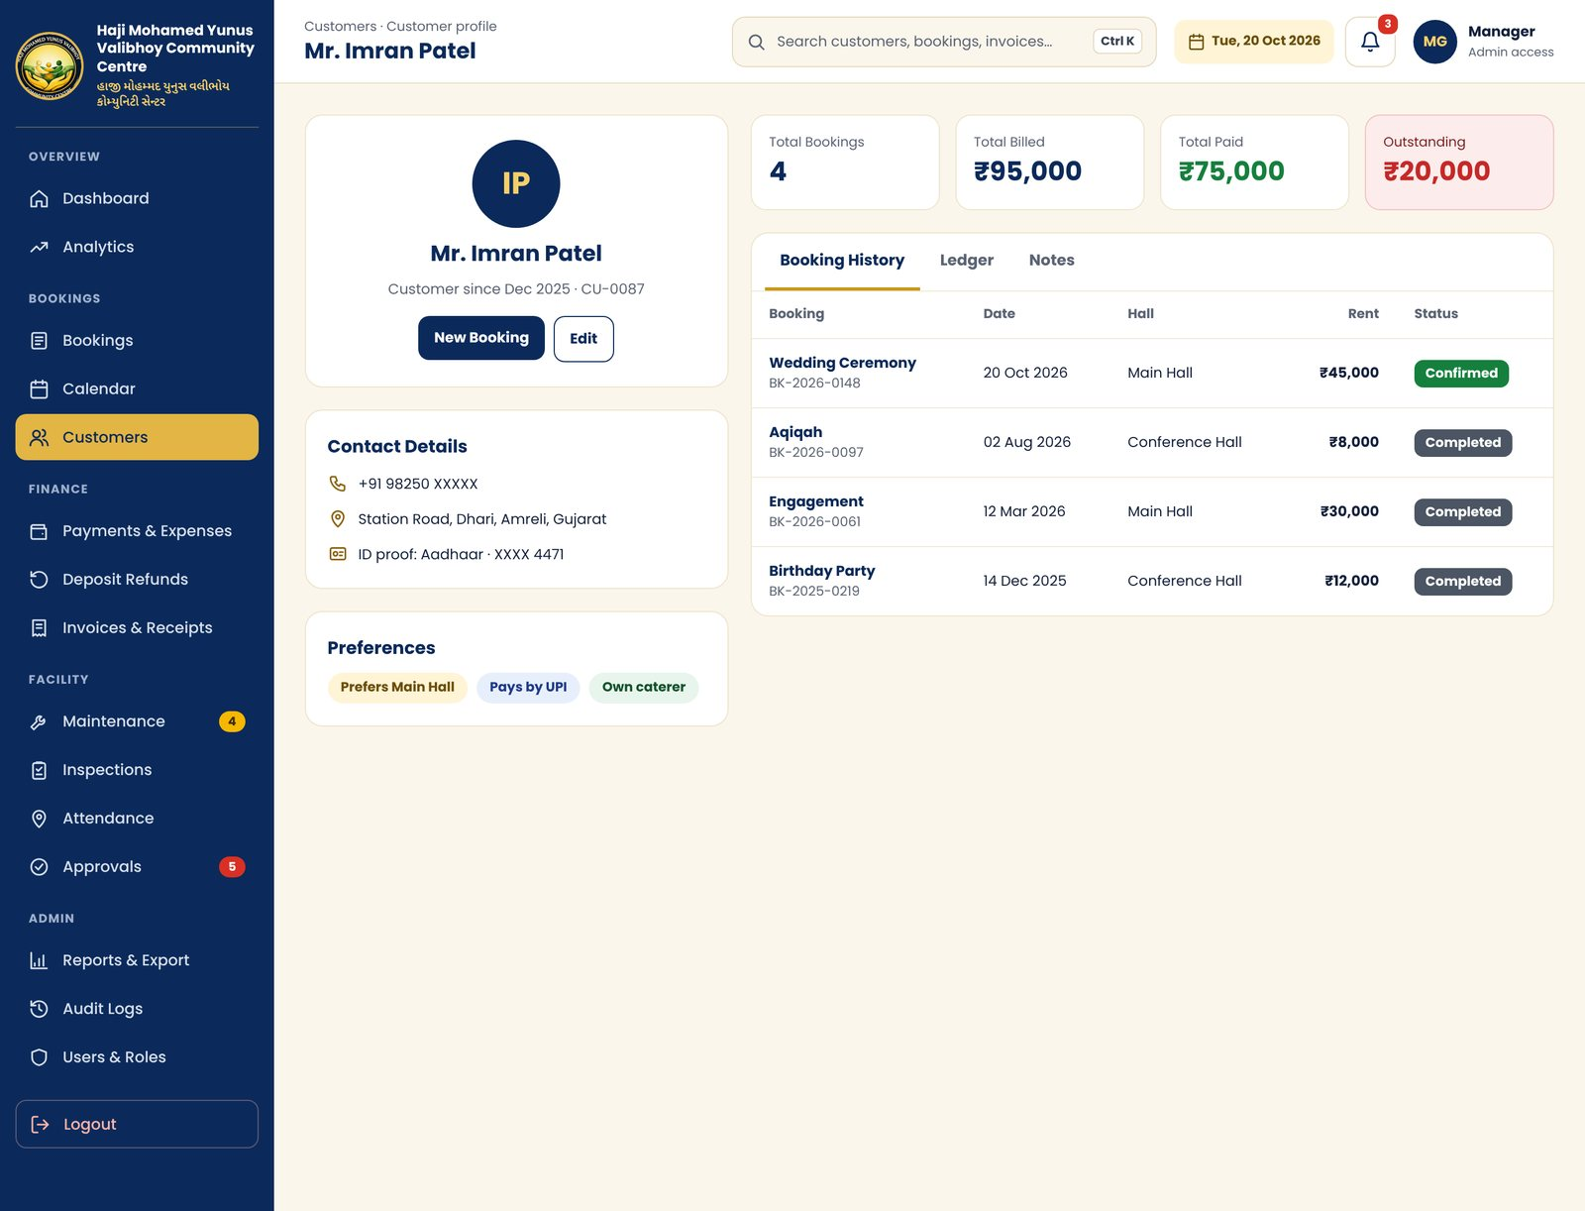
KEY ELEMENTS
- Profile card with New Booking and Edit
- Contact details and ID proof (masked)
- Preference tags
- Billed, paid and outstanding totals
- Tabs: Booking History, Ledger (debit, credit, running balance), Notes
NOTES
Tabs are interactive in the prototype.

4.10 Payments & Expenses
Route: /payments File: app/(app)/payments/page.tsx
Record rent and deposits, track expenses and chase overdue payments.
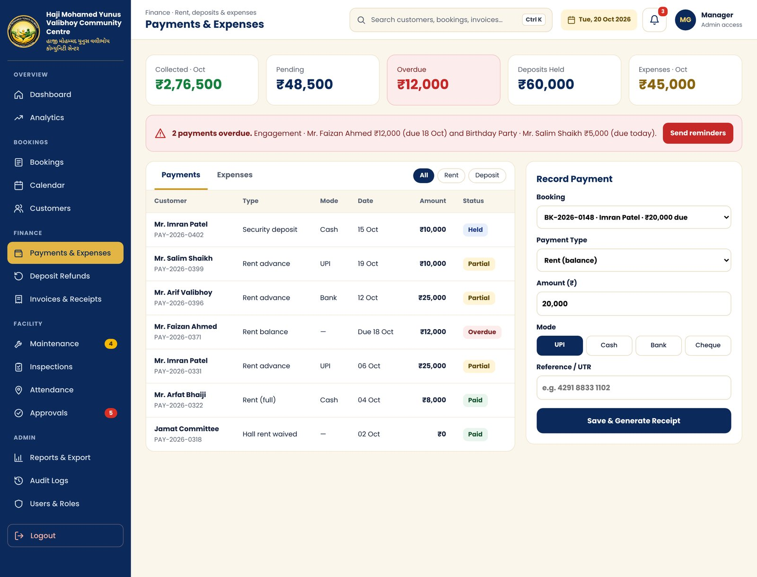
KEY ELEMENTS
- KPIs: collected, pending, overdue, deposits held, expenses
- Overdue alert banner with Send reminders
- Tabs: Payments and Expenses, each with its own table and status chips
- Record Payment form: booking, type, amount, mode (UPI, Cash, Bank, Cheque), reference, Save & Generate Receipt
NOTES
Reminders are in-app for now; WhatsApp and SMS come in Phase 2.

4.11 Deposit Refund
Route: /deposits/[id] File: app/(app)/deposits/[id]/page.tsx
Settle a security deposit after the post-event inspection.
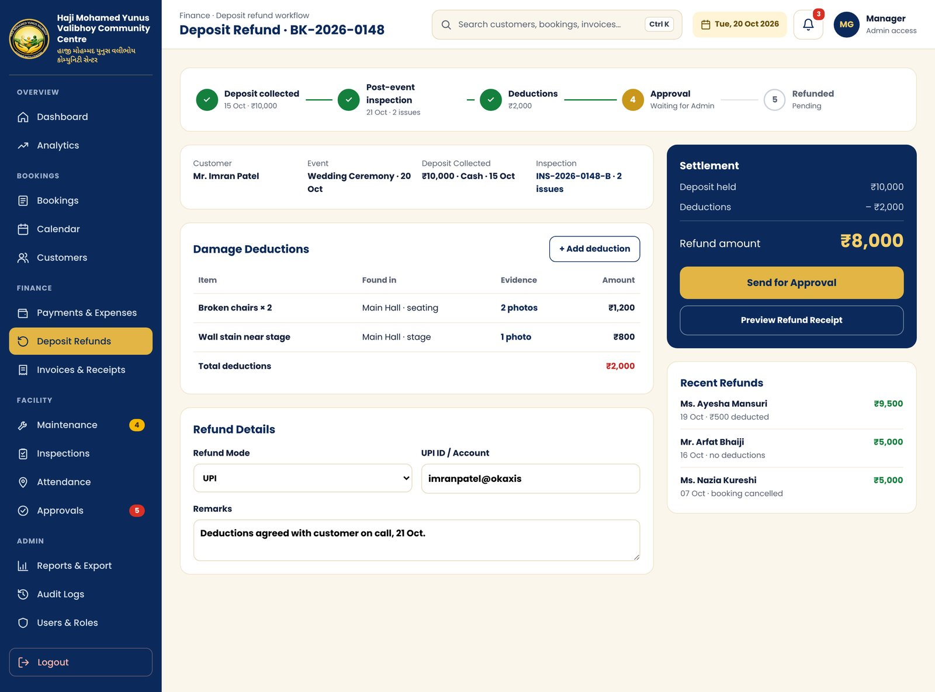
KEY ELEMENTS
- Five-step progress: collected, inspection, deductions, approval, refunded
- Booking and inspection summary
- Damage deductions table with photo evidence
- Refund mode, UPI or account, remarks
- Settlement panel: held, deductions, refund amount, Send for Approval, refund receipt preview
- Recent refunds list
NOTES
Suggested module 07. Refunds need approval before payout.

4.12 Invoices & Receipts
Route: /invoices/[id] File: app/(app)/invoices/[id]/page.tsx
Generate printable documents for any booking.
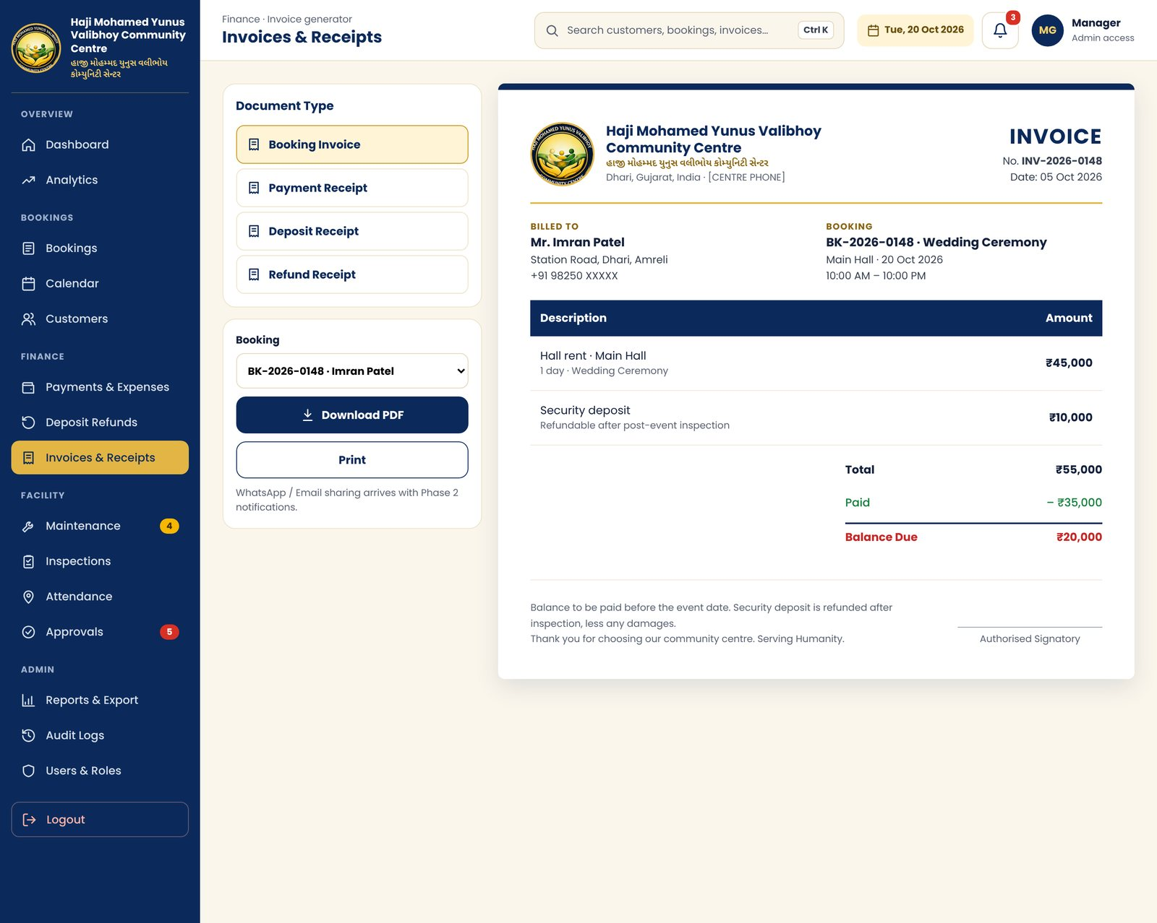
KEY ELEMENTS
- Document type: Booking Invoice, Payment Receipt, Deposit Receipt, Refund Receipt
- Booking picker, Download PDF, Print
- A4-style preview with logo, English and Gujarati name, billed-to, booking details, line items, totals, notes and signature line
NOTES
Switching document type changes the preview in the prototype. Centre phone number is a placeholder.

4.13 Maintenance Requests
Route: /maintenance File: app/(app)/maintenance/page.tsx
Ticket list for all repair and upkeep work.
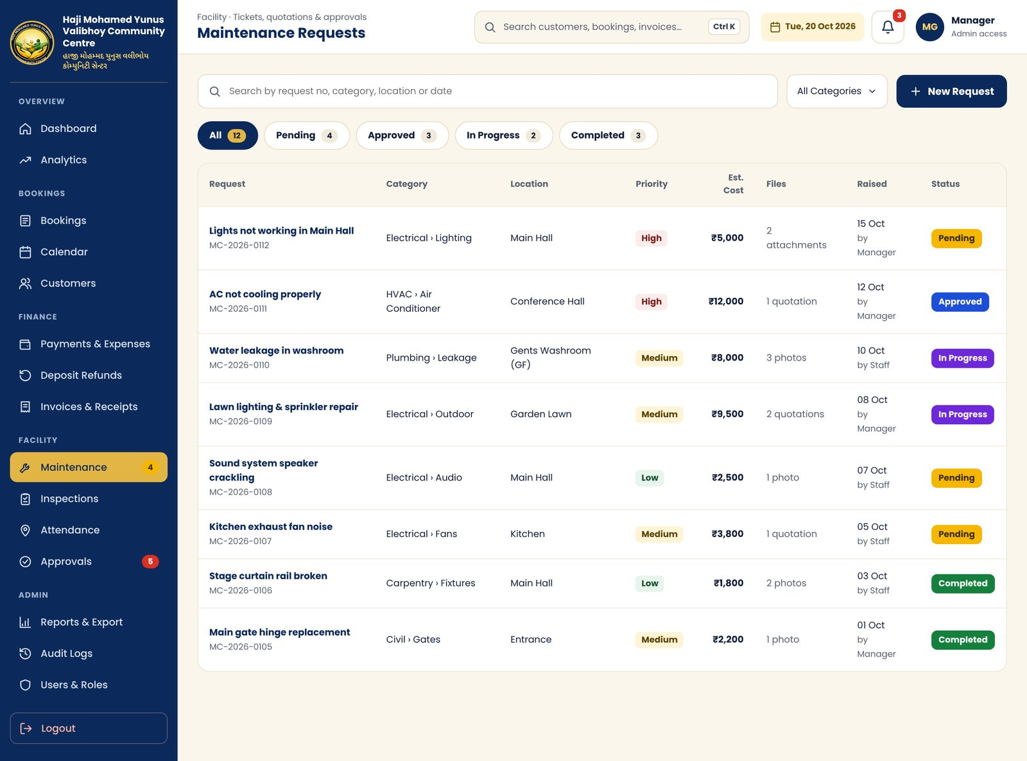
KEY ELEMENTS
- Search, category filter, New Request
- Status tabs with counts: All, Pending, Approved, In Progress, Completed
- Table: request and number, category, location, priority, estimated cost, attachments, raised date and by, status
NOTES
Request numbers follow MC-YYYY-NNNN, matching your reference screens.

4.14 New Maintenance Request
Route: /maintenance/new File: app/(app)/maintenance/new/page.tsx
Raise a ticket with quotations, photos and an optional calendar block.
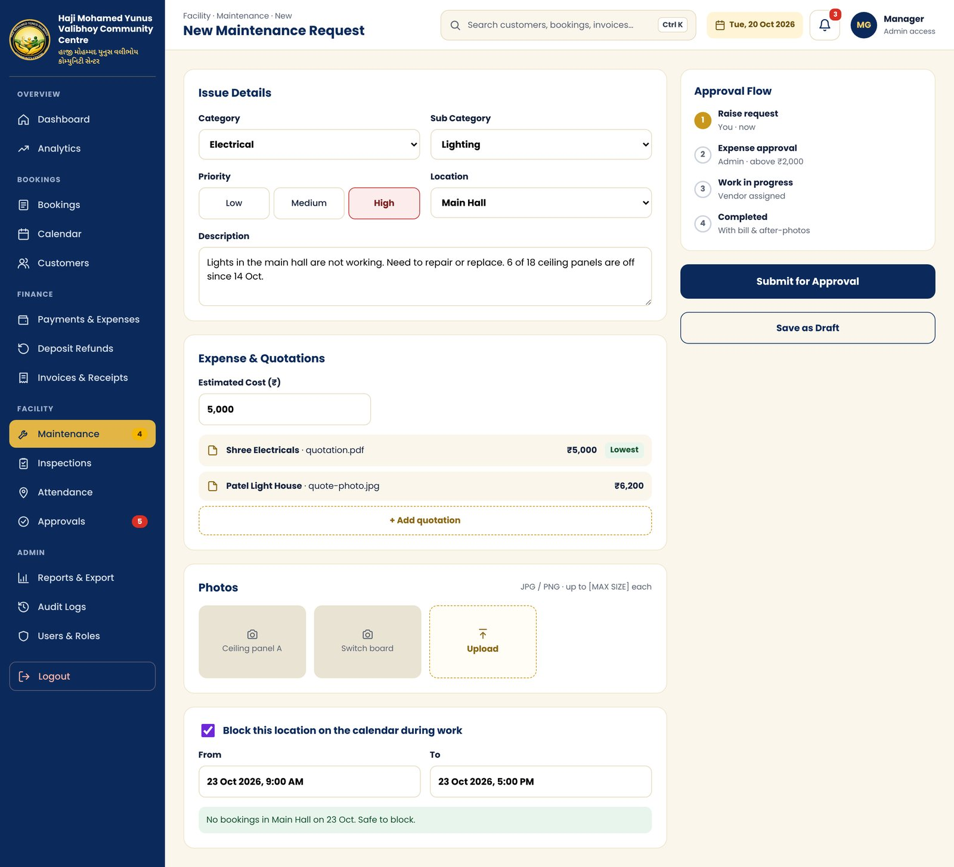
KEY ELEMENTS
- Category, sub category, priority (Low, Medium, High), location, description
- Estimated cost and vendor quotations (lowest is highlighted)
- Photo upload grid
- Block this location on the calendar, with clash check
- Approval flow panel, Submit for Approval, Save as Draft
NOTES
Based on your reference mobile form. Upload size limit is a placeholder until confirmed.

4.15 Property Inspection
Route: /inspections/[id] File: app/(app)/inspections/[id]/page.tsx
Before and after event checks that feed the deposit refund.
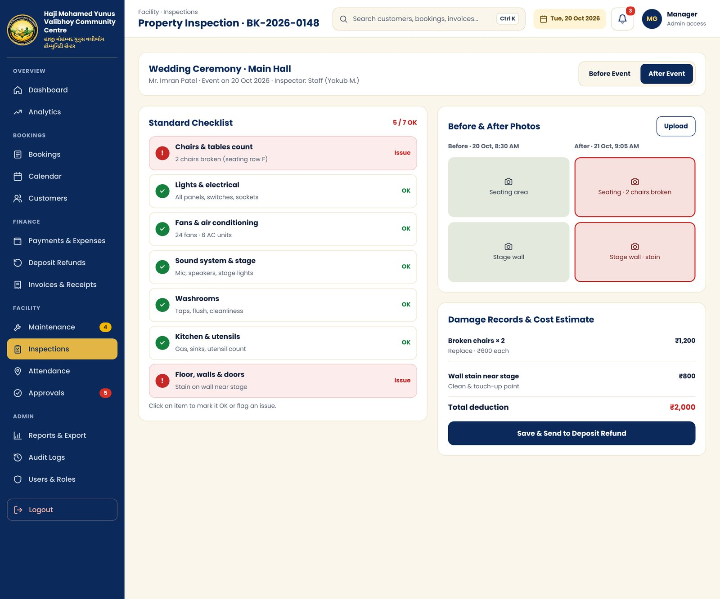
KEY ELEMENTS
- Before Event / After Event switch
- Seven-point standard checklist (chairs, electrical, fans and AC, sound, washrooms, kitchen, floors and walls)
- Before and after photo pairs, issues outlined in red
- Damage records with cost estimate and total deduction
- Save & Send to Deposit Refund
NOTES
Checklist items toggle between OK and Issue in the prototype.

4.16 Attendance (GPS)
Route: /attendance File: app/(app)/attendance/page.tsx
Staff check-in and check-out with location verification.
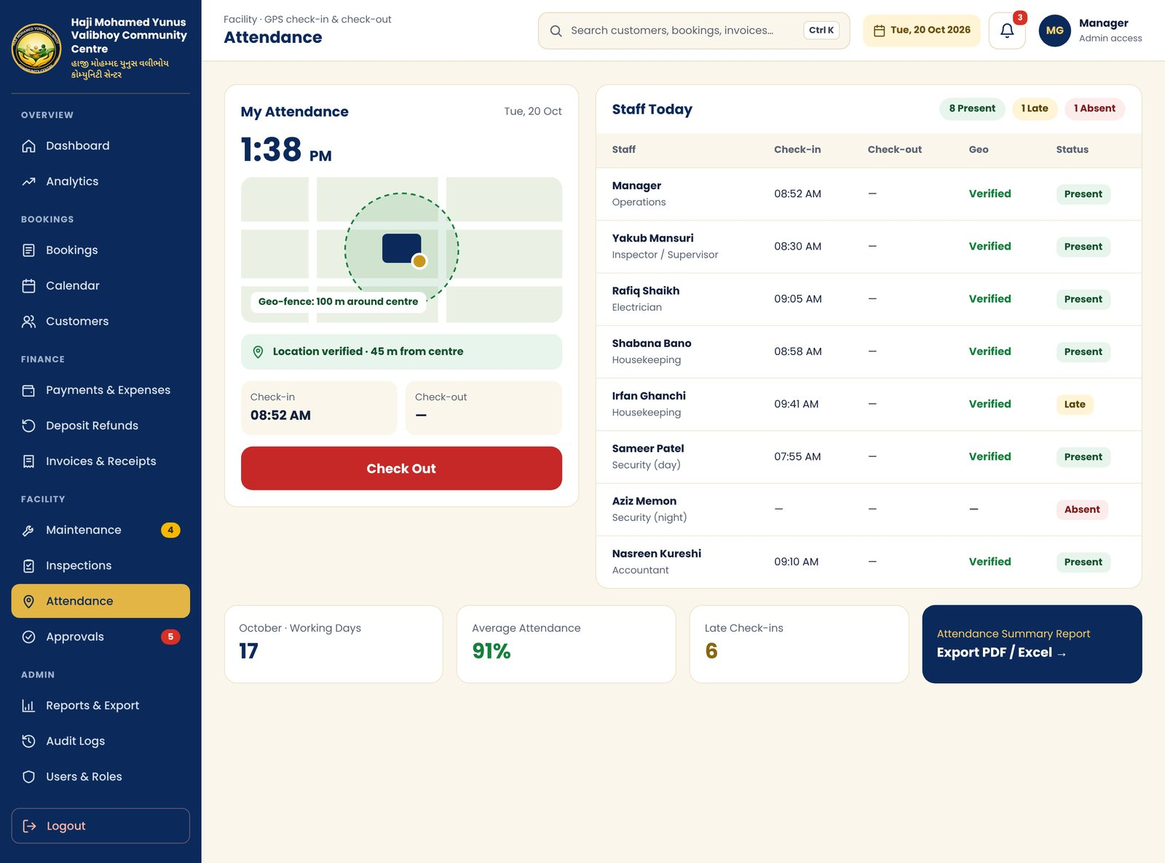
KEY ELEMENTS
- My Attendance card: clock, geo-fence map, location verified message, check-in and check-out times
- Check In / Check Out button
- Staff Today table with times, geo status and Present, Late, Absent chips
- Monthly summary and link to the attendance report
NOTES
Geo-fence radius (100 m shown) to be confirmed. Button cycles through states in the prototype.

4.17 Approvals
Route: /approvals File: app/(app)/approvals/page.tsx
One queue for expense, maintenance and refund approvals.
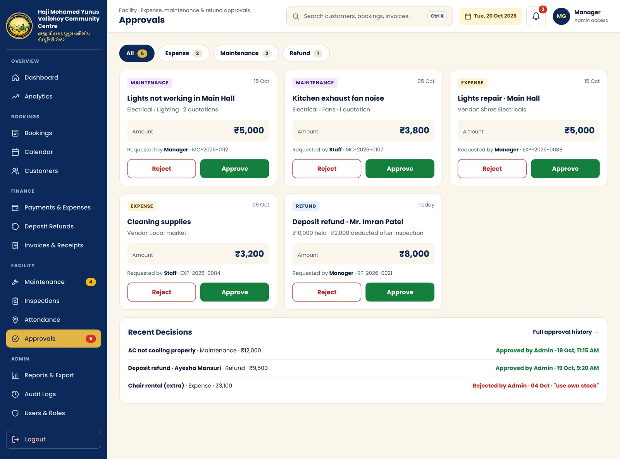
KEY ELEMENTS
- Type tabs with counts
- Approval cards: type, title, details, amount, requester, reference, Approve and Reject
- Recent decisions with approver and time
NOTES
Approve and Reject work in the prototype, with Undo. Every decision is written to the audit log.

4.18 Notification Center
Route: /notifications File: app/(app)/notifications/page.tsx
All alerts in one list.
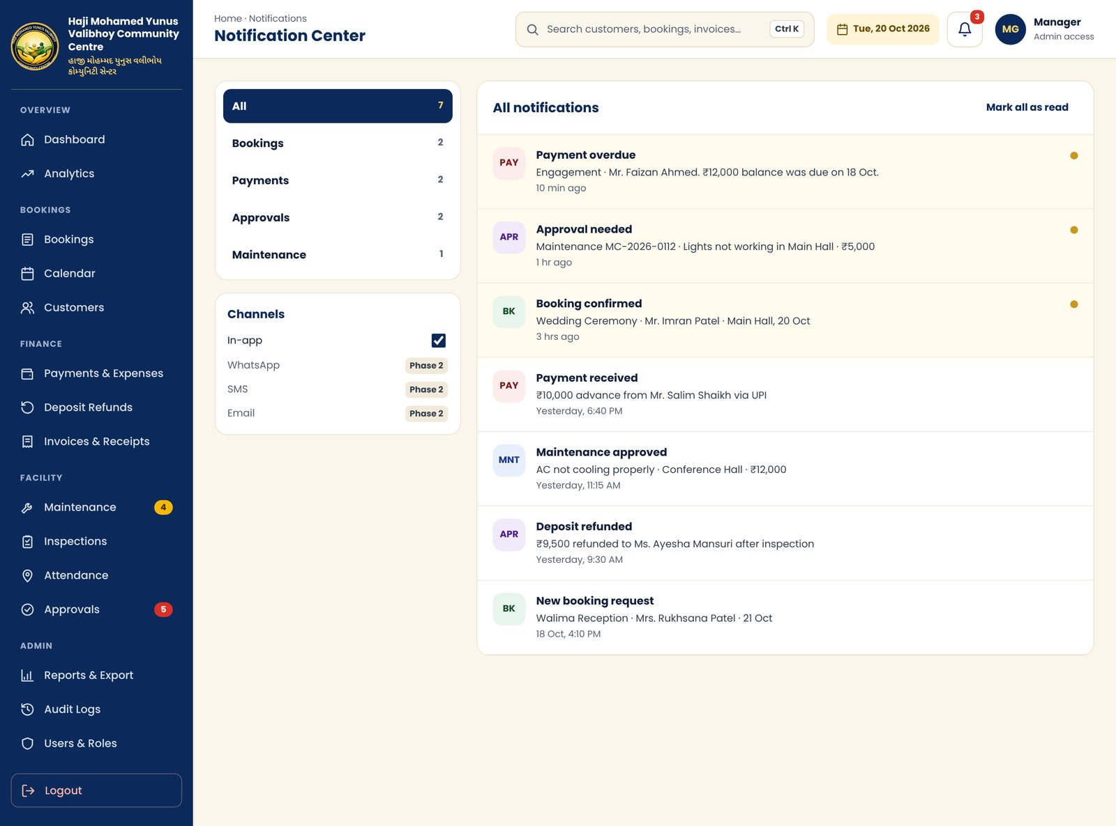
KEY ELEMENTS
- Category filter: All, Bookings, Payments, Approvals, Maintenance
- Notification rows with type badge, message, time and unread dot
- Mark all as read
- Channels panel: in-app now; WhatsApp, SMS and Email marked Phase 2
NOTES
Suggested module 12. The bell in the top bar shows the unread count.

4.19 Global Search
Route: /search File: app/(app)/search/page.tsx
Search customers, bookings, payments, invoices and maintenance from one box.
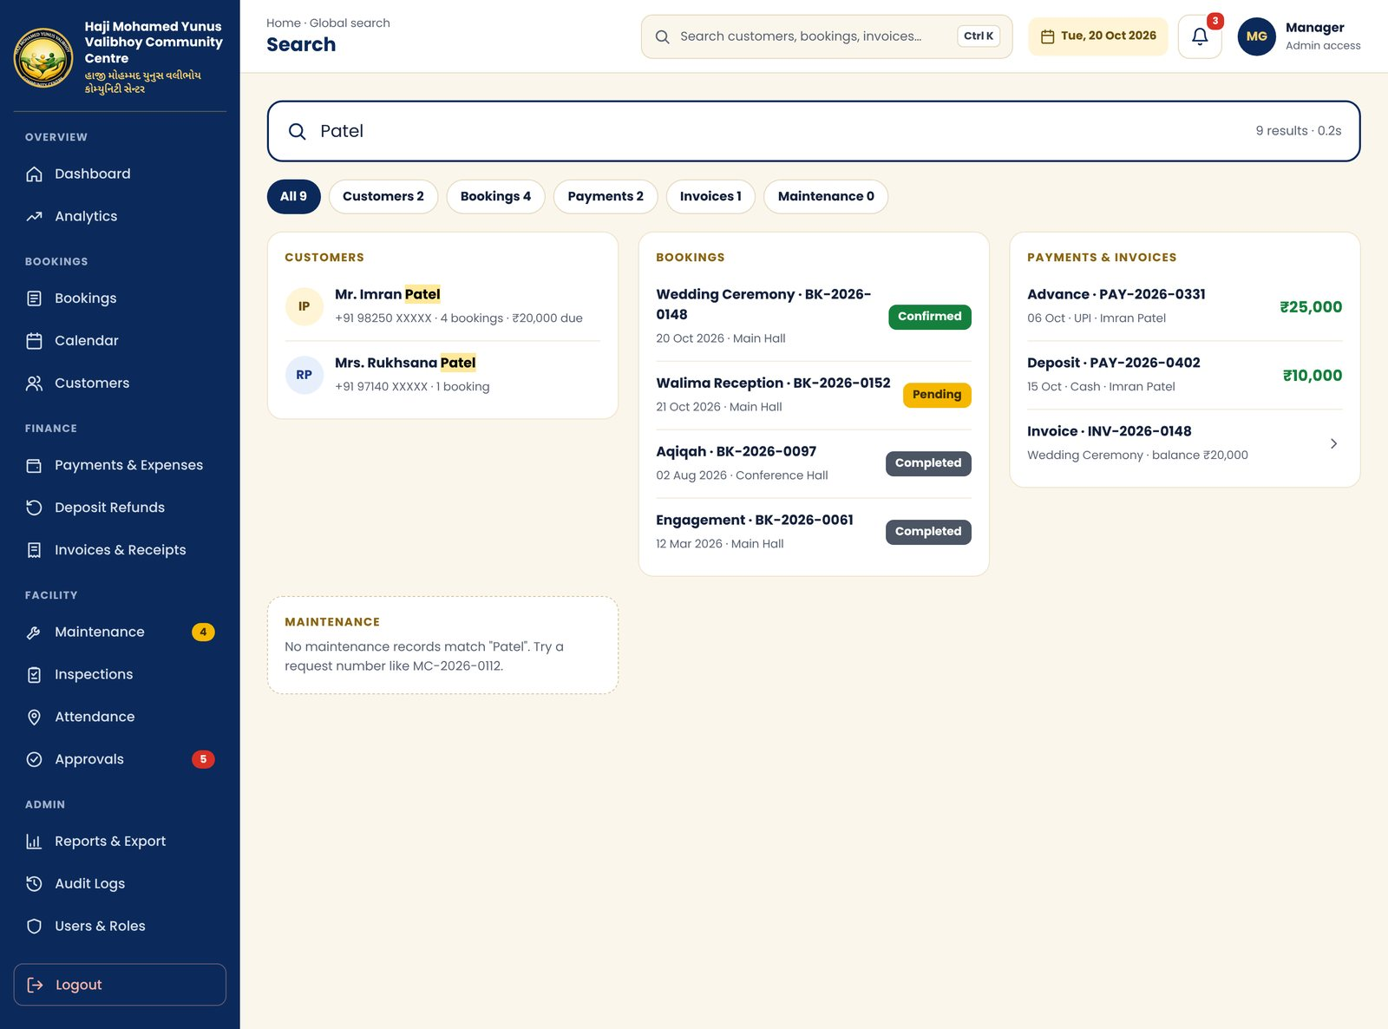
KEY ELEMENTS
- Large search field with result count
- Result-type chips with counts
- Grouped result cards with matches highlighted
- Empty-state message for groups with no results
NOTES
Suggested module 15. Opened from the top-bar search or Ctrl K.

4.20 Reports & Export
Route: /reports File: app/(app)/reports/page.tsx
Date-range reports with PDF and Excel export.
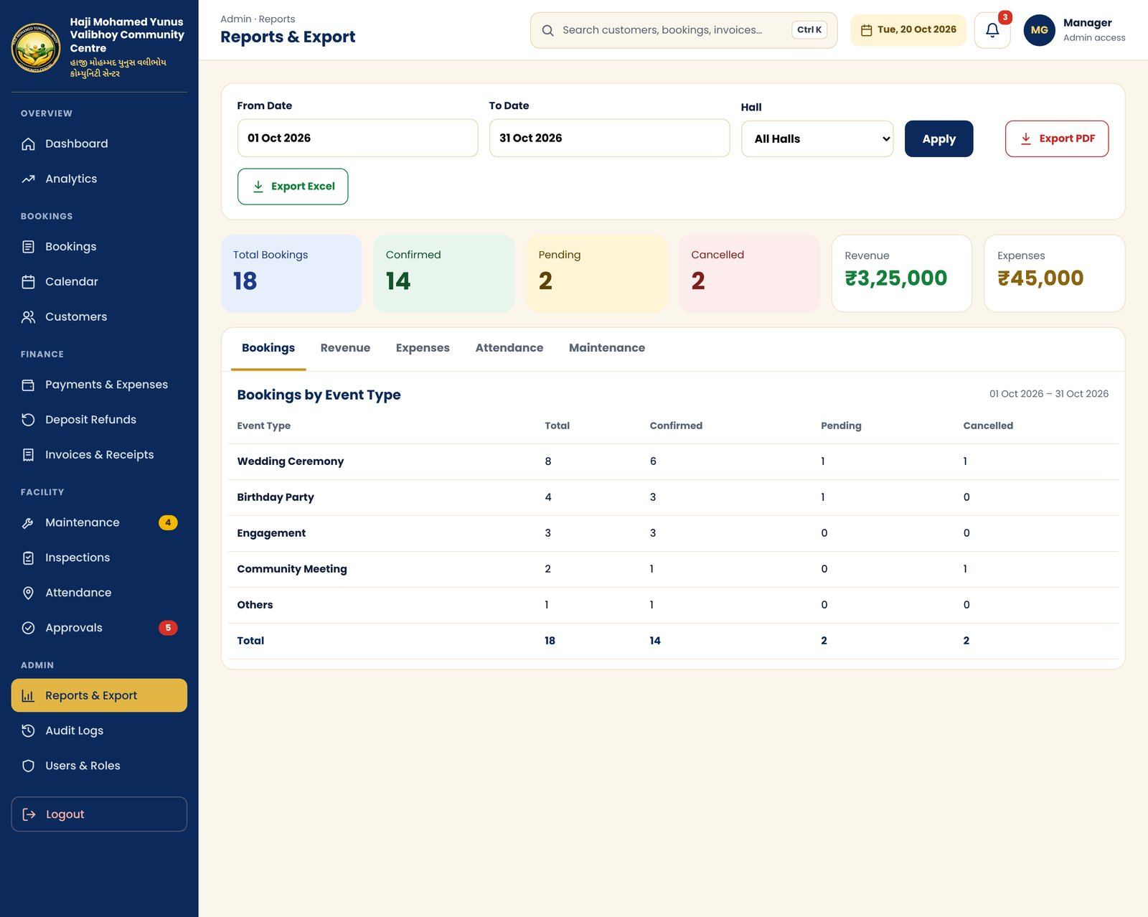
KEY ELEMENTS
- From and To dates, hall filter, Apply, Export PDF, Export Excel
- Summary tiles: total, confirmed, pending, cancelled, revenue, expenses
- Report tabs: Bookings, Revenue, Expenses, Attendance, Maintenance, each with its own table and totals row
NOTES
Based on your reference Reports screen. Tabs are interactive in the prototype.

4.21 Activity & Audit Logs
Route: /audit-logs File: app/(app)/audit-logs/page.tsx
Read-only history of who changed what and when.
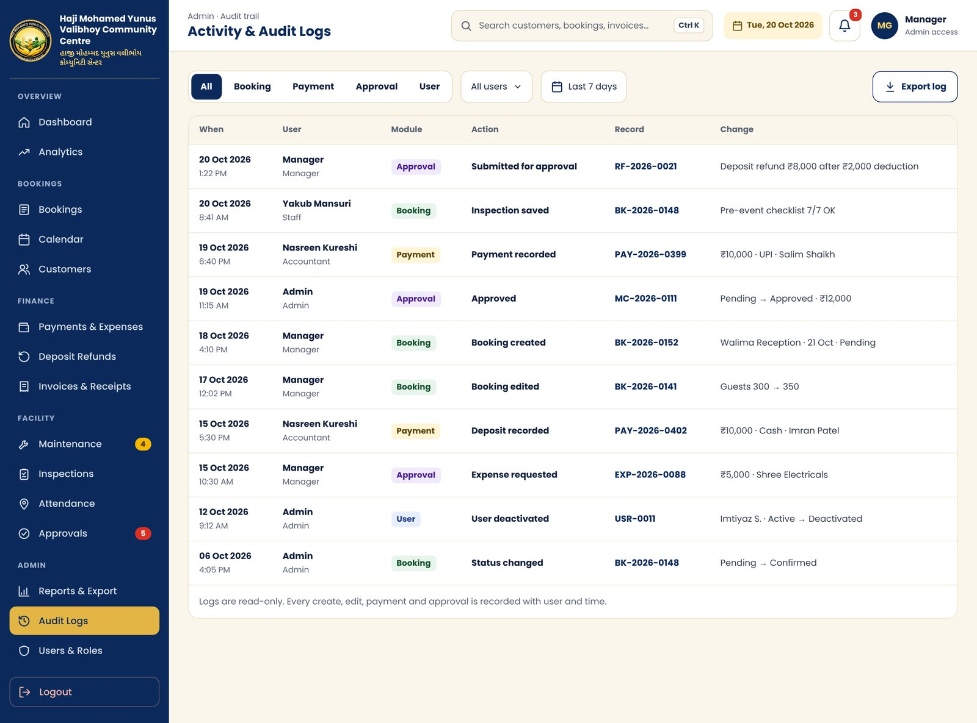
KEY ELEMENTS
- Module tabs: All, Booking, Payment, Approval, User
- User and date filters, Export log
- Table: time, user and role, module, action, record link, change (before and after)
NOTES
Covers booking, payment and approval history from proposal item 18.

4.22 Users, Roles & Permissions
Route: /settings/users File: app/(app)/settings/users/page.tsx
Create, edit and deactivate users, and control what each role can do.
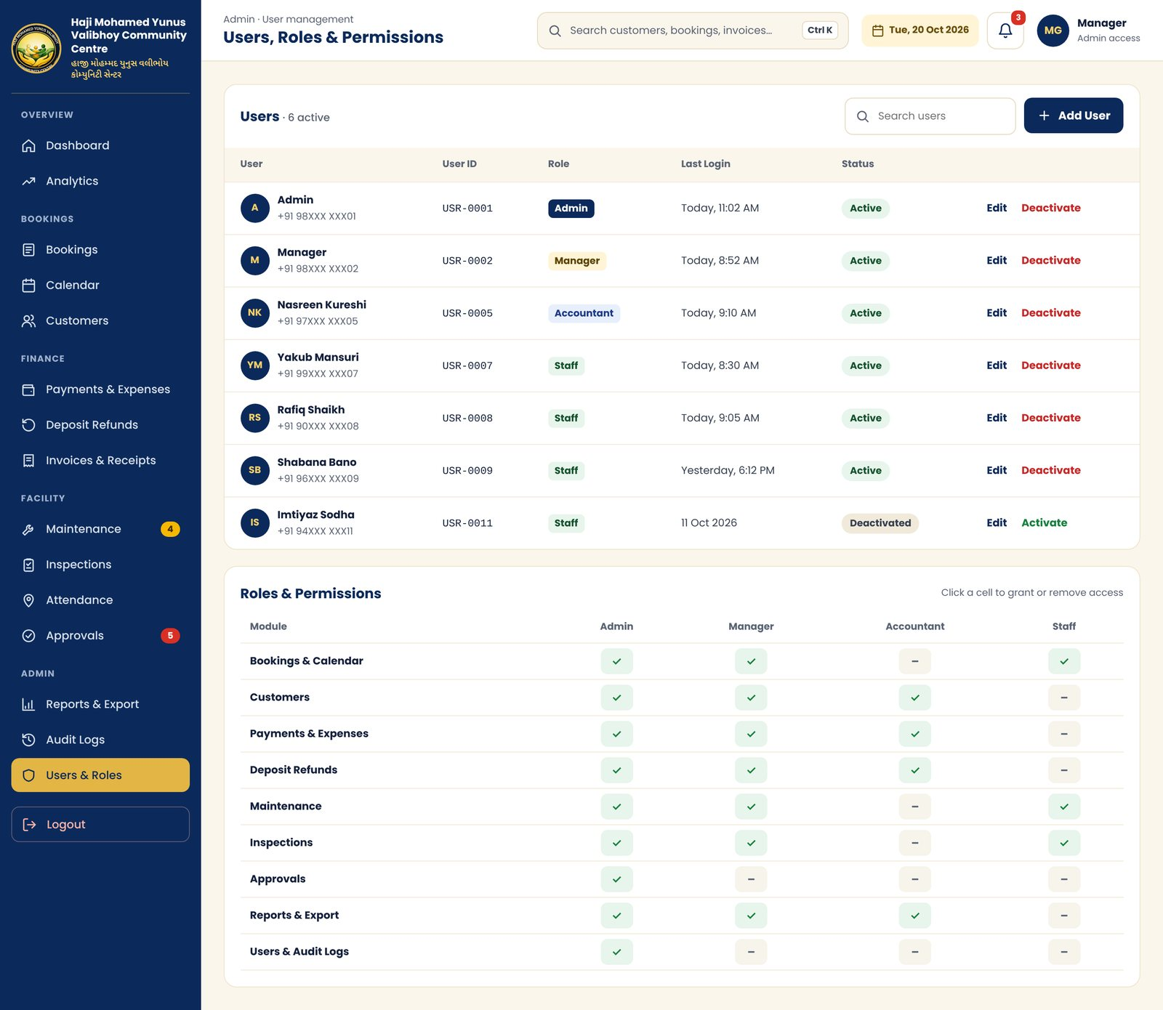
KEY ELEMENTS
- User table: name, user ID, role, last login, status, Edit, Activate or Deactivate
- Roles and permissions grid: modules by Admin, Manager, Accountant, Staff
NOTES
Deactivate and the permission grid are interactive in the prototype. Roles shown are suggestions to confirm.

5. Mobile Screens
Mobile follows the client’s reference layout: navy header with logo, English and Gujarati name and a gold curve, cream background, card-based content and a six-item bottom tab bar (Home, Bookings, Calendar, Maintenance, Reports, More). Screens are drawn at 390 px width. Modules not shown here reuse the desktop page content in a single column.

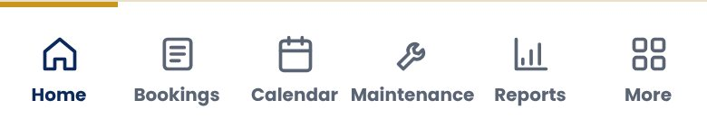
Shared mobile header and bottom tab bar

5.1 Login
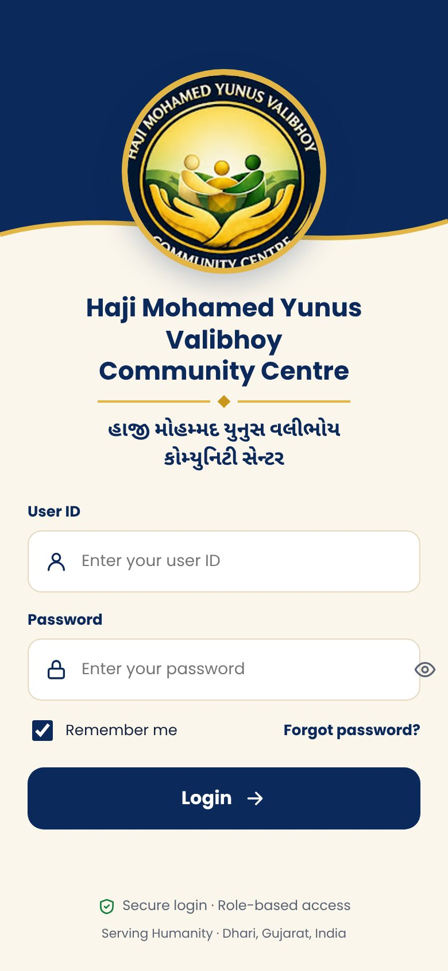 | WHAT IT SHOWS  Logo on navy header with gold curve, English and Gujarati name, User ID and password.

5.2 Dashboard
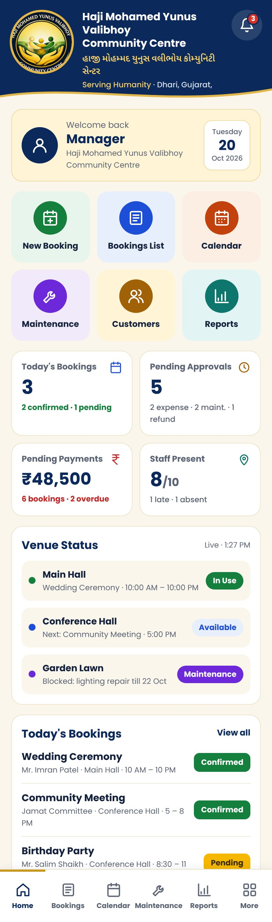 | WHAT IT SHOWS  Welcome card, six quick-action tiles, four KPI cards, venue status, today’s bookings, attendance.

5.3 More Menu
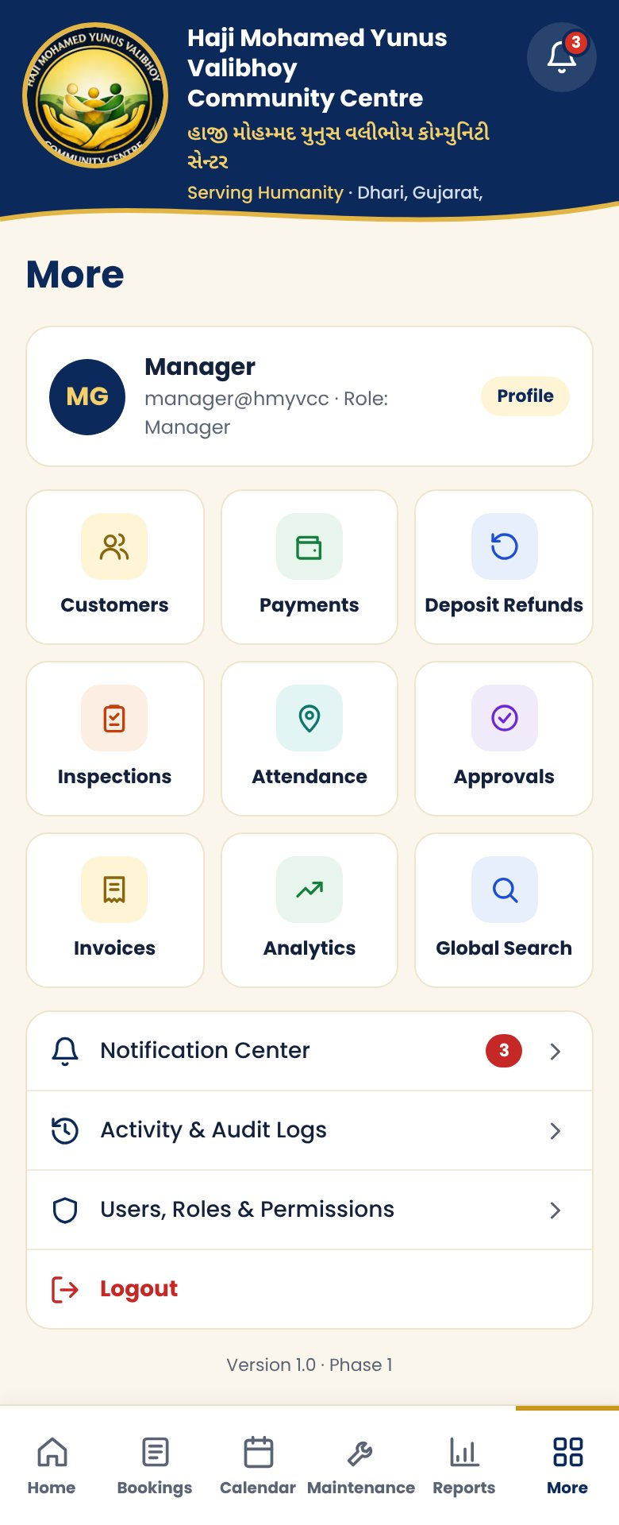 | WHAT IT SHOWS  Profile, grid of remaining modules, notifications, audit logs, users, logout.

5.4 Notification Center
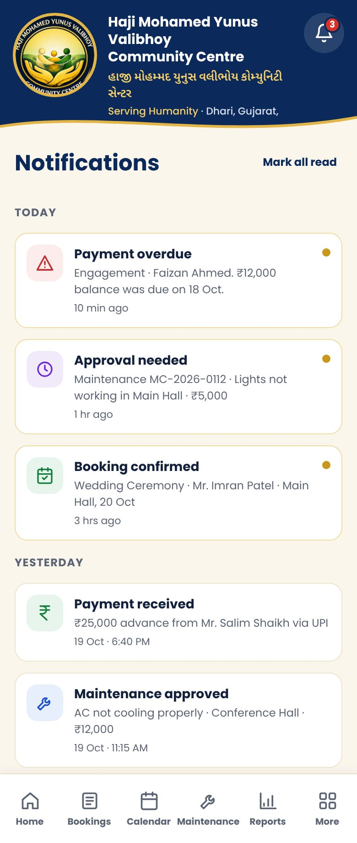 | WHAT IT SHOWS  Filter chips, Today and Yesterday groups, unread dots.

5.5 Global Search
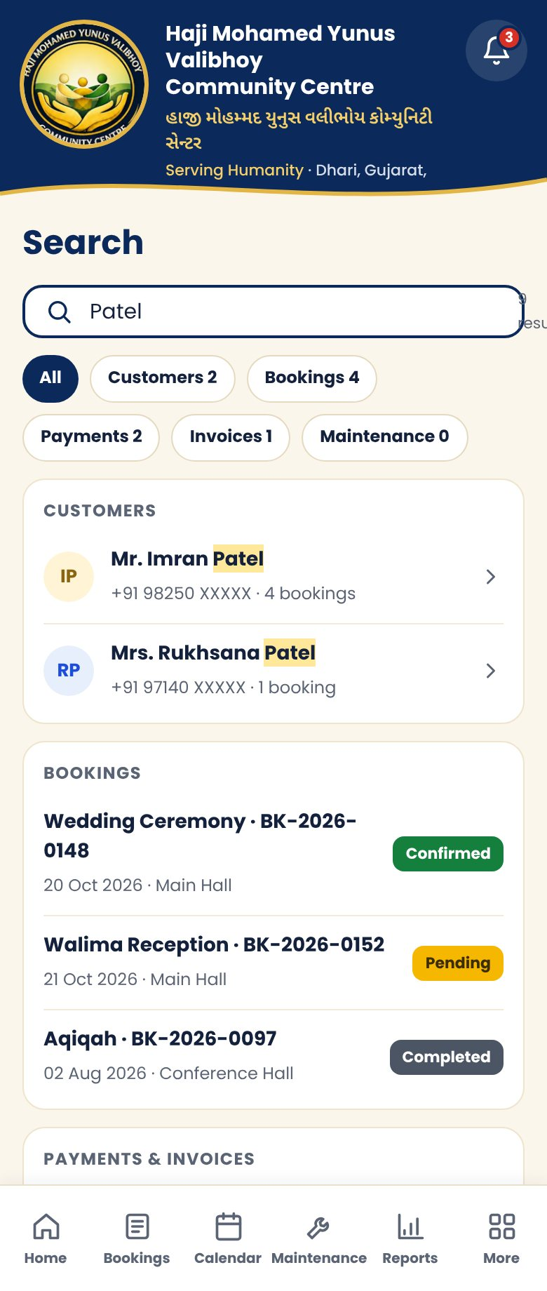 | WHAT IT SHOWS  Search field, result-type chips, grouped results.

5.6 Bookings List
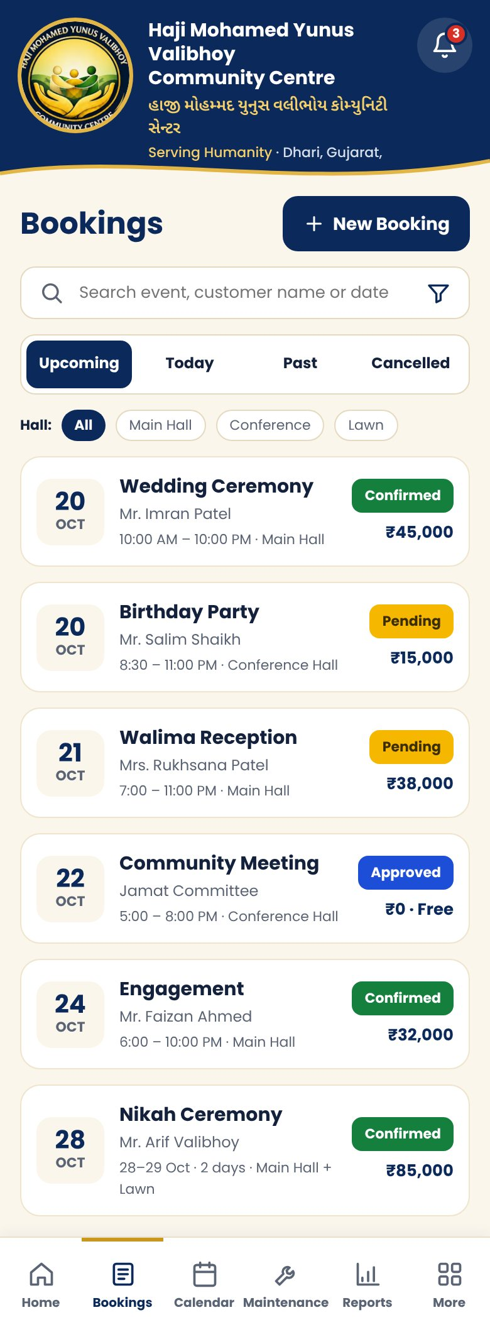 | WHAT IT SHOWS  Search, Upcoming / Today / Past / Cancelled tabs, hall chips, booking cards with status and amount.

5.7 New Booking
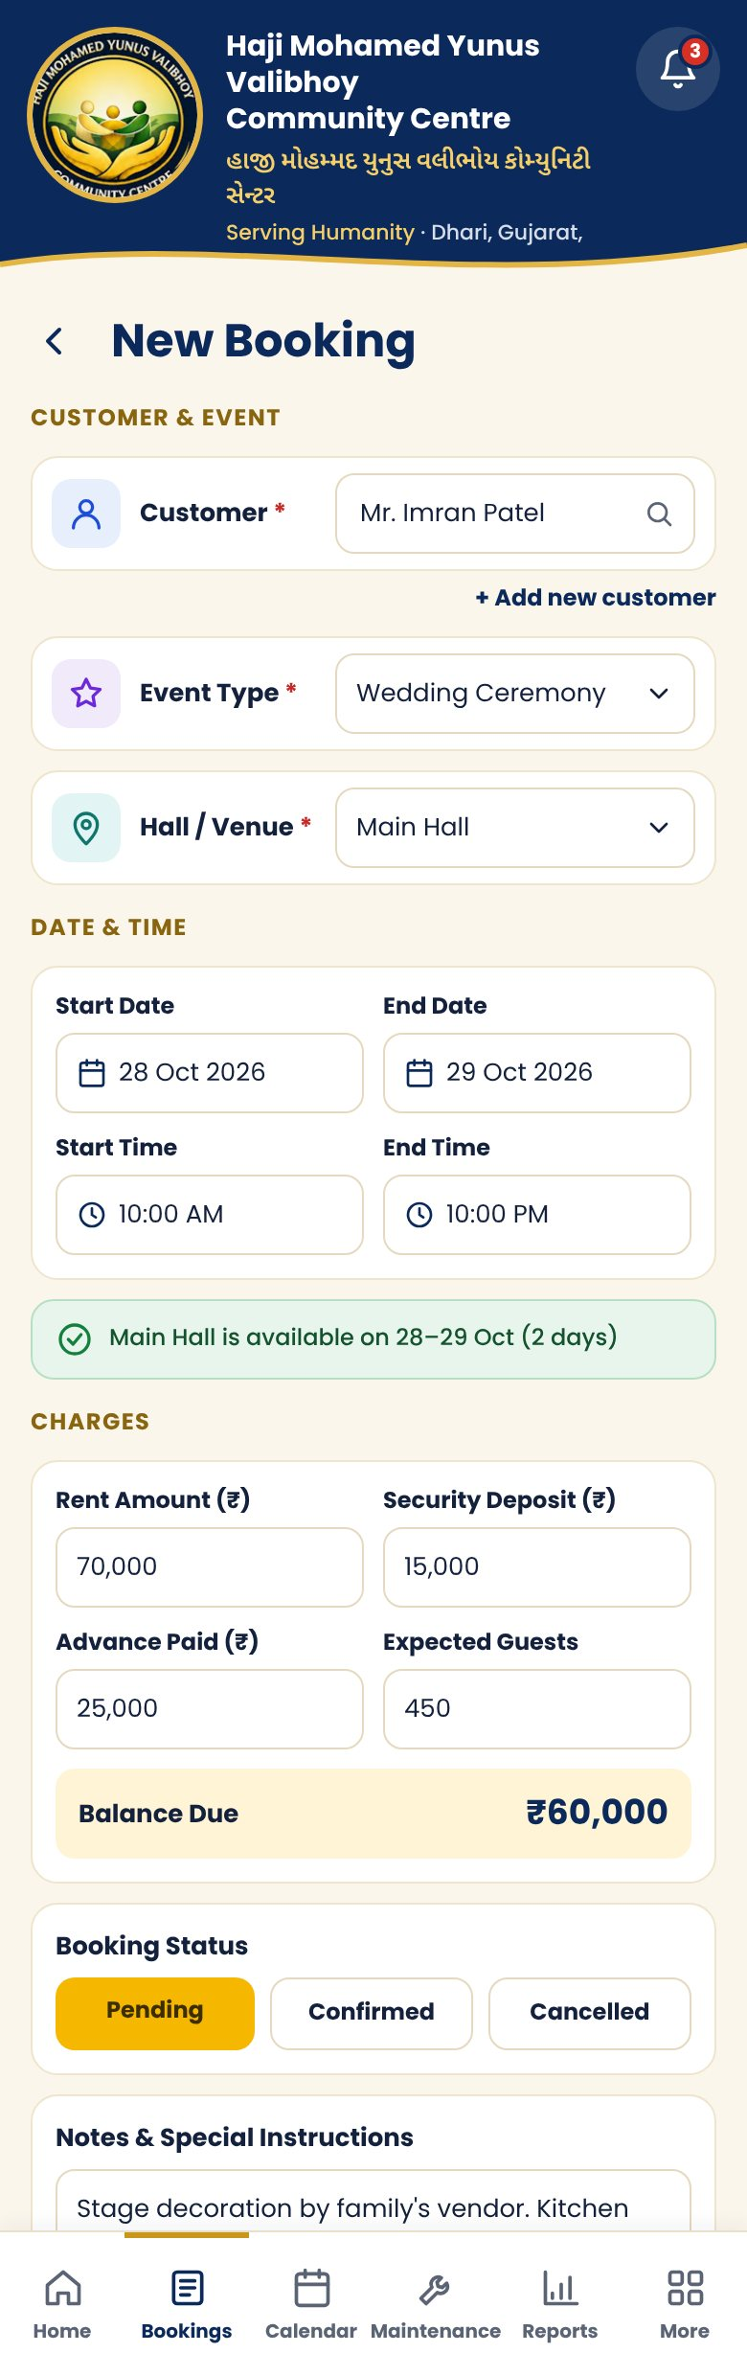 | WHAT IT SHOWS  Same fields as desktop in a single column, availability check, balance due.

5.8 Booking Details & Timeline
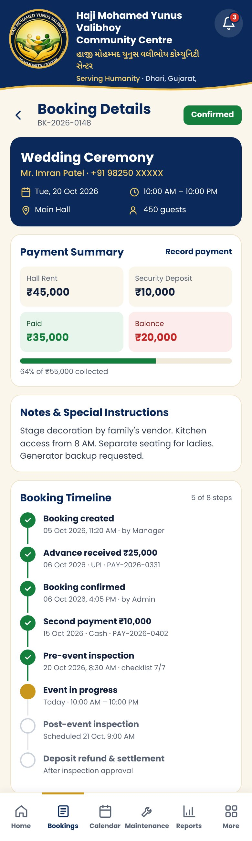 | WHAT IT SHOWS  Event card, payment summary, notes, timeline, Edit / Invoice / Cancel.

5.9 Calendar
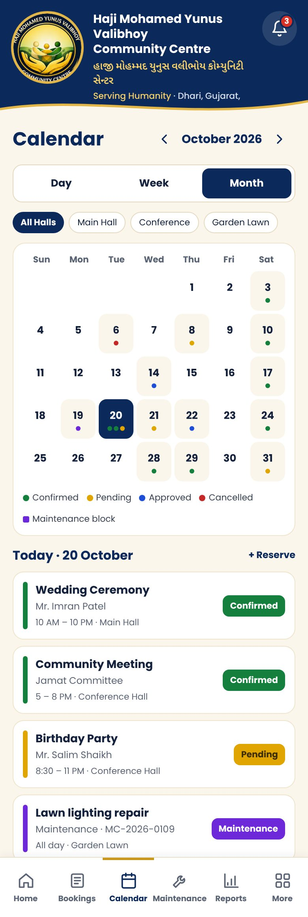 | WHAT IT SHOWS  Compact month grid with status dots and the selected day’s list.

6. Files in this Package
Folder | Contents
Design-Spec.docx | This document
screenshots/desktop | 22 desktop pages plus sidebar and top bar, PNG at 2x (2880 px wide)
screenshots/mobile | 9 mobile screens plus header and tab bar, PNG at 2x
html-preview | Static HTML snapshot of every screen; open index.html in a browser
design-source | Original design files (.dc.html) and canvas.json from the design canvas
OPEN QUESTIONS FROM THE PROPOSAL
- Booking: multiple days, multiple bookings per day, number of halls, booked separately?
- File uploads: maximum size, allowed types, video support?
- Data: archive or delete removed records; how long to keep bookings and files?
- Design: confirm colours and branding; which reports matter most on day one?

